**READY TO BE BOUND. READY TO DIE**

Acts 21:1-39 (Key verse: 21:13)

*Then Paul answered, “Why are you weeping and breaking my heart?*

*I am ready not only to be bound, but also to die in Jerusalem for the name of the Lord Jesus.”*

1. Describe Paul’s parting from the Ephesian elders? (1a; 20:36-38) Where did they land? (1b-3; map) Why did the disciples in Tyre urge Paul not to go on to Jerusalem? (4[1]) But what was Paul’s response? (5a) Why? Did he not believe what they told him? (20:22-24) Describe their parting. (5b-6)
2. Where and with whom did they stay in Caesarea? (7-9) What do you think was the spiritual environment like in Philip’s house? How might this have helped Paul to prepare to go to Jerusalem? After a number of days, who came from Judea and what did he do? (10-11a) What was the prophecy of Agabus? (11b)
3. How did Luke and the others respond to this prophecy? (12) How did Paul respond? (13) How could Paul be “ready” to give up his life like this for Jesus? What did Paul’s travel companion realized and do? (14) What do you learn here from Paul about what is required to make a decision to obey God’s will for your life?
4. Describe Paul’s quiet arrival in Jerusalem? (15-17) What did Paul report to James and the elders of the Jerusalem church? (18-19) How did the believers in Jerusalem respond to Paul’s world mission report? (20a) But what concern overshadowed Paul’s report? (20b-22) What did they suggest? (23-25) How did Paul comply? (26) Why?
5. What happened while Paul was in the temple? (27-29) How did the riot escalate? (30-31a) How was Paul saved? (31b-34) Yet, how great was the violence of the mob by now? (35-36) What shows Paul’s courage? (37-39) How does this prove that Paul was truly ready to be bound, ready to die for the name of the Lord Jesus.

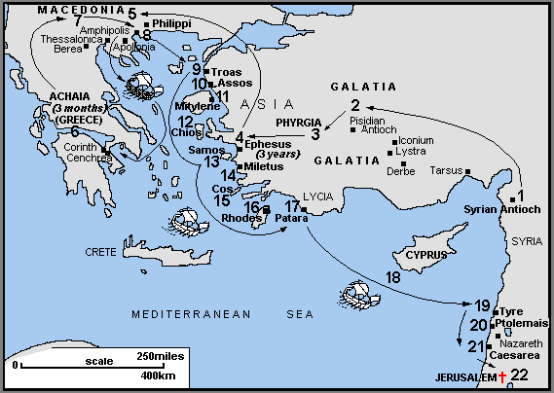

1. It is confusing that the disciples urged Paul through the Spirit! The Holy Spirit had been compelling Paul to go to Jerusalem (20:22). Was the Holy Spirit now telling Paul not to go to Jerusalem? No, not at all. Rather, the Christians in Tyre expressed their deep compassion and love for Paul through the Holy Spirit. They were like a loving mother sending her son off to war. She may know that he has to go, but she expresses undying affection for him and seeks any alternative to spare him